FIRST OF ALL, JUST GO THE COMMAND PRO GIVE THE COMMAND TO FIND THE MACHINE.

1 (ping payments.luthersales.com) Then you will find the Ip address copy the ip address

2 [34.68.24.251 ..prod-konga-key cloak] this is the machine

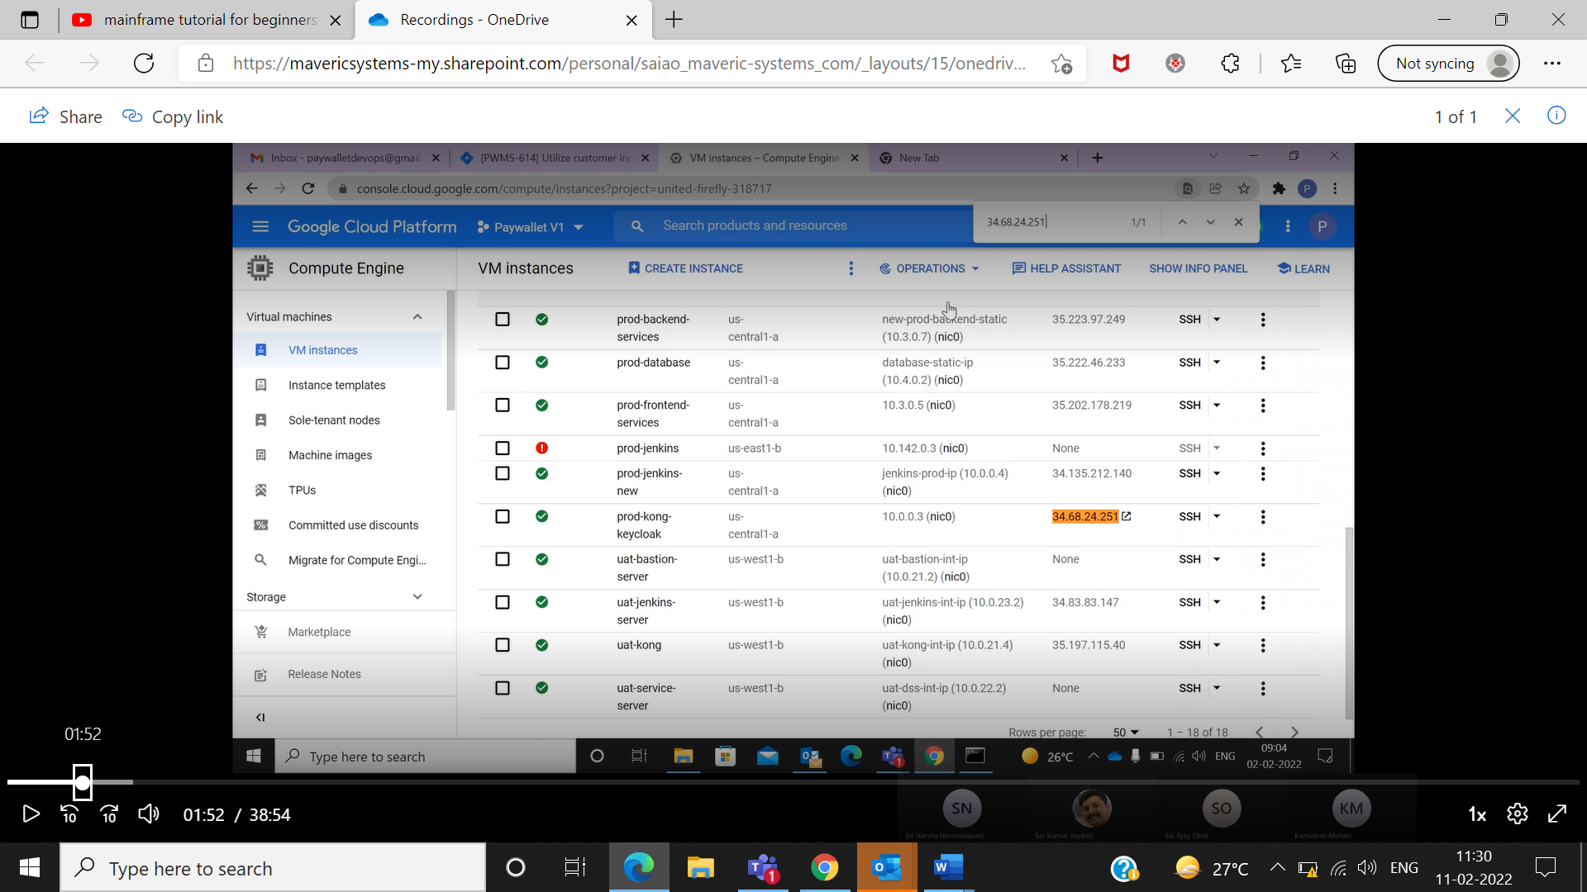

3 just connect to that machine…which is highlighted on orange colour..

4. now we need to down the Luther sale process is just give the following commands

-docker ps-a ,

-Sudo -i

-docker ps-a

-then copy the container id (03b8)

-docker stop 03b8

Now the Luthersale is down now …

- Then systemctl1 status apache2

-cd /etc/

-cd /

-find . -name certbot

-certbot certonly –standalone

-(please enter the domain name payments.luthersales.com

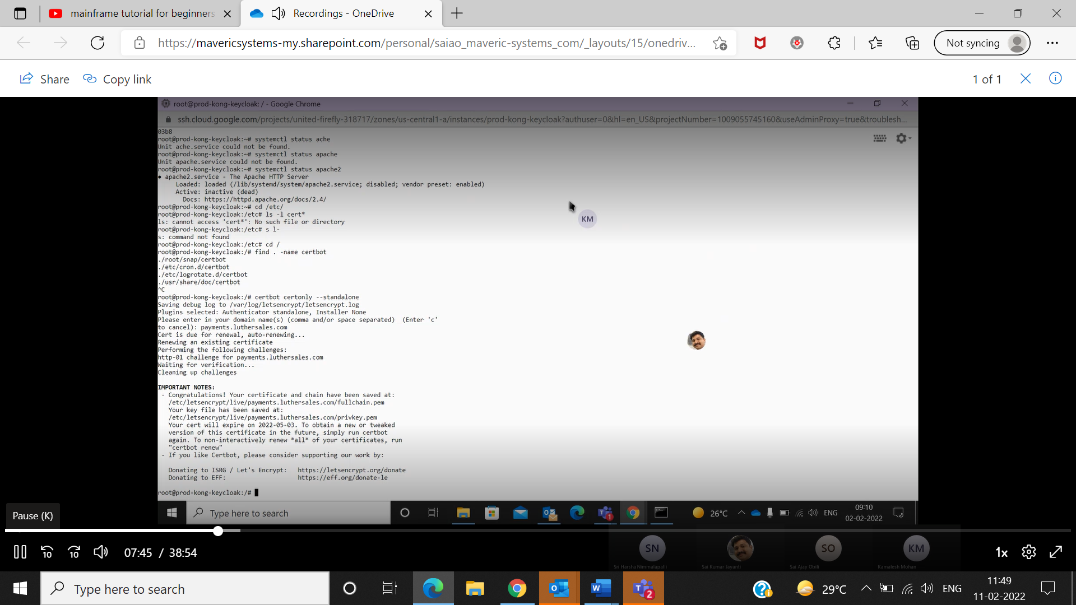

HINT…. To do this certificate just give the command ”certbot renew” no need to give all this command just based on our knowledge we just mention another process …..which will understand better …but for that you need to shutdown Luther sale which is the process mention above…

THEN PLEASE CHECK IT IS INACTIVE BY GIVIING THE COMMAND ( systemctl status apache2)

Now we can bring back Luther sale

docker ps-a

docker start 03 ( the Luther sales is come back)

now give the command

(cat /etc/letsencrypt/live/payments.luthersales.com/fullchain.pem)

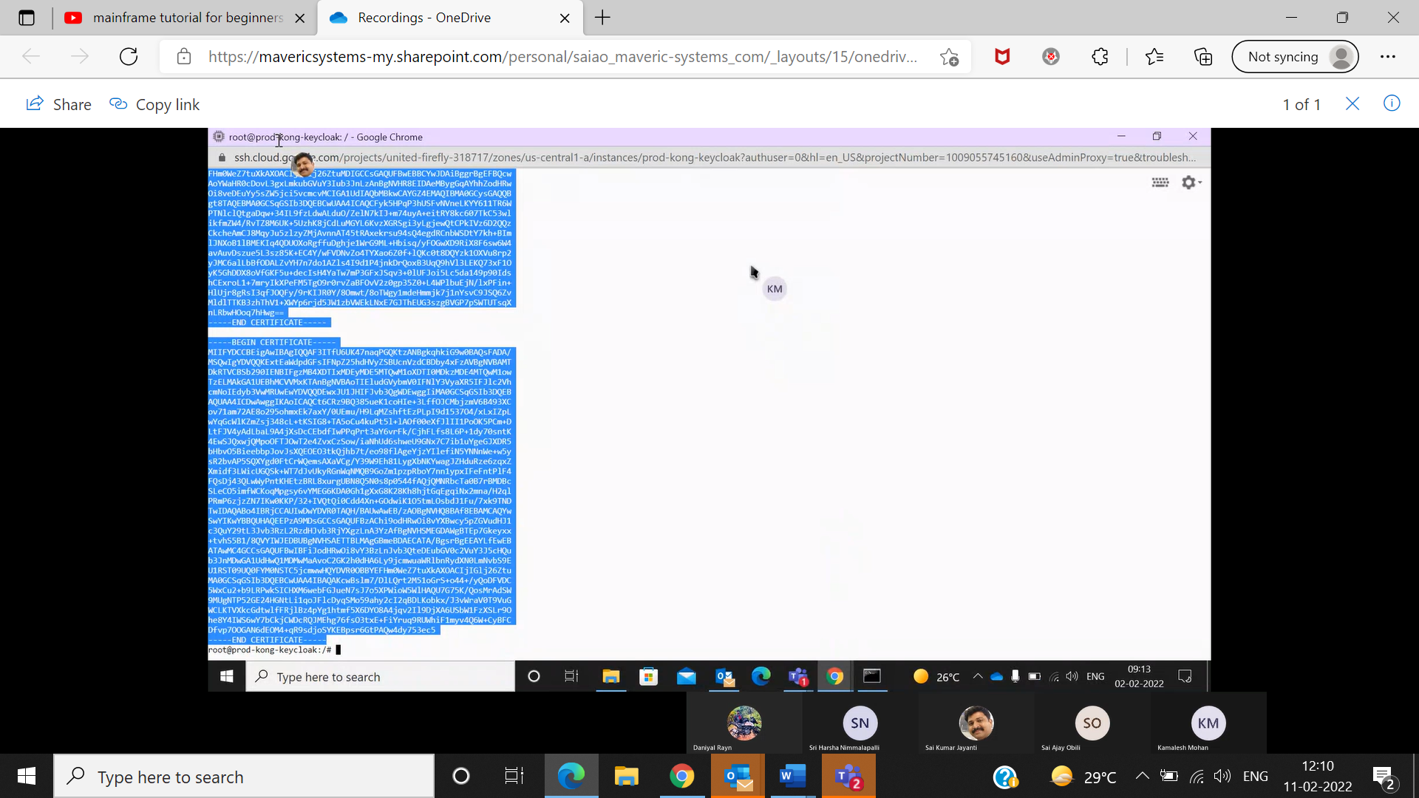

Just copy this all 3 content in notepad..

Then go to google.com <http://34.68.24.251:1337> this is the konga

Then open konga will open just give the credential of this konga

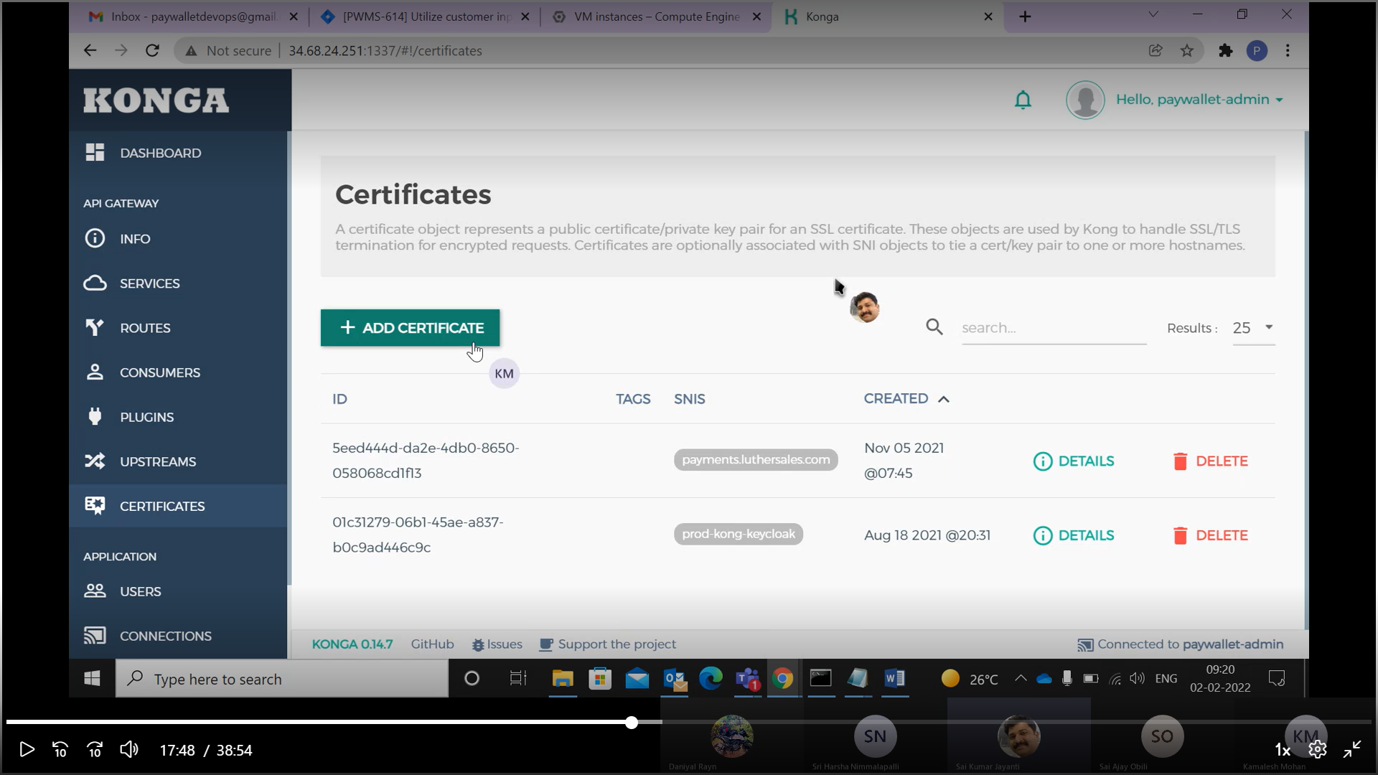

In CERTIFICATES just click then ADD CERTIFICATE

In CERTIFICATE JUST COPY ALL 3 CONTENT WHICH WE COPY IT AND ADD IN NOTEPAD EARLIER ie.. LIKE THIS WHICH IS SHOWING IN BELOW IMAGE

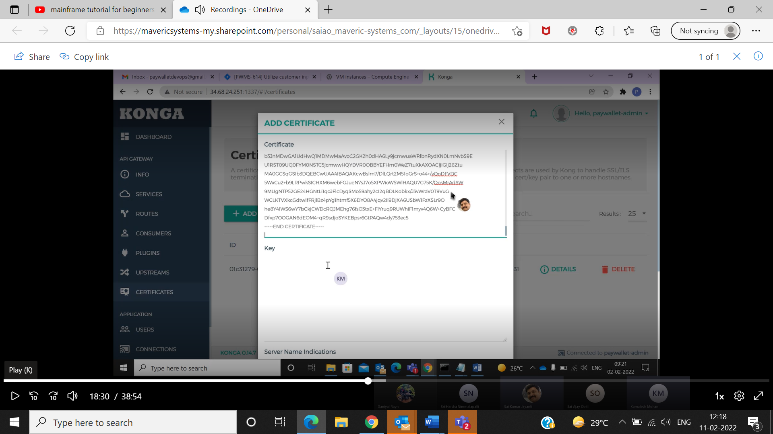

NOW GO TO THE TERMINAL AGAIN THEN GIVE THE COMMAND

(cat /etc/letsencrypt/live/payments.luthersales.com/privatekey.pem)

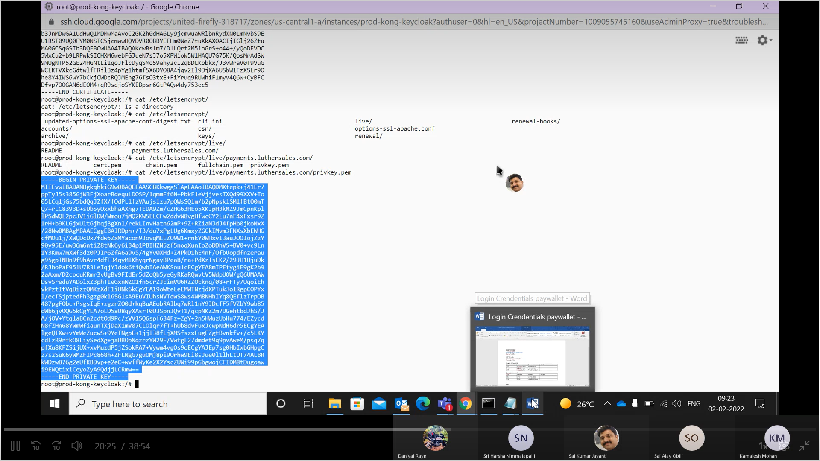

Copy the content then go to the konga certificate page

And paste its in KEY -LIKE WHICH IS SHOWS IN BELOW IMAGE

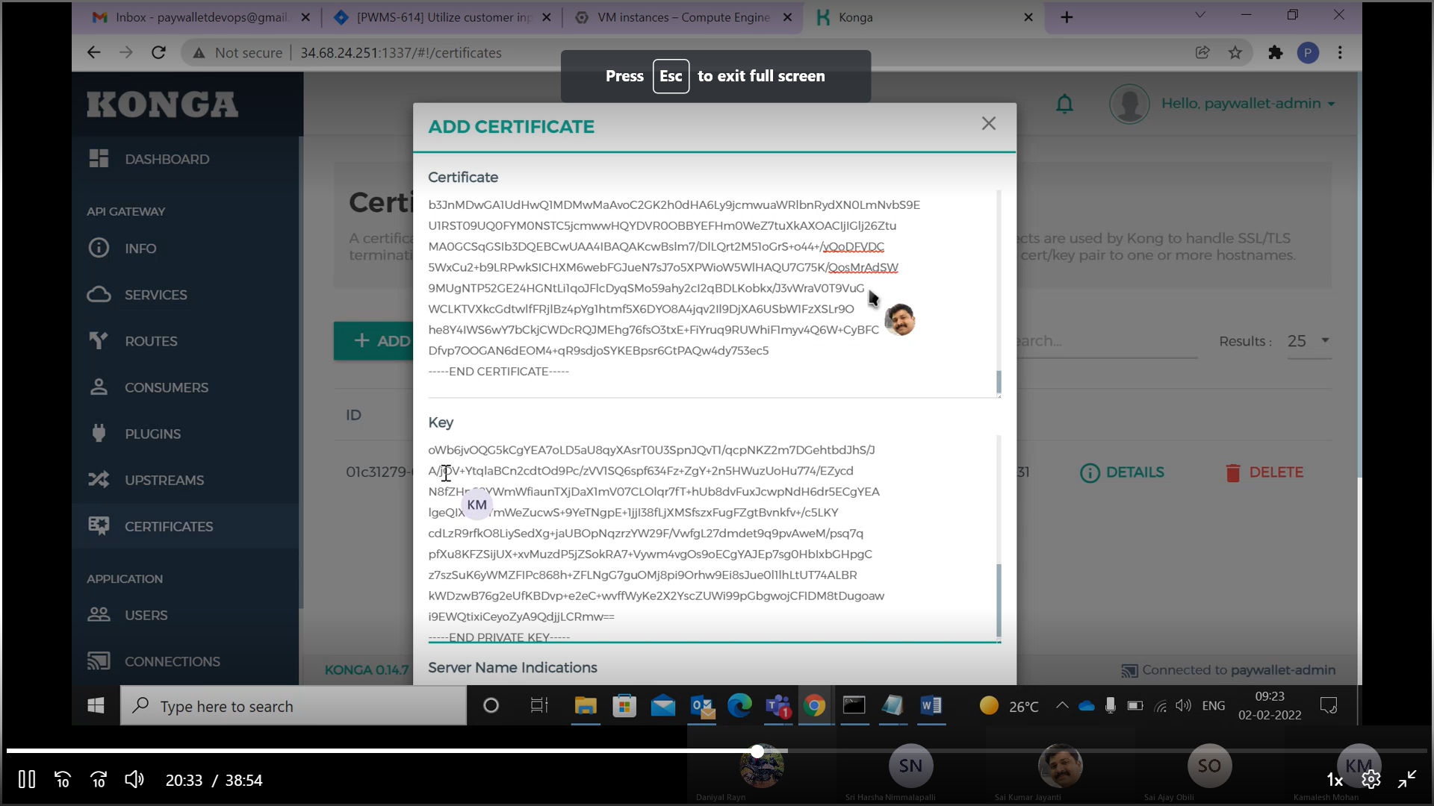

Now in SERVER NAME INDICATIONS, JUST GIVE THE ( payments.luthersales.com )

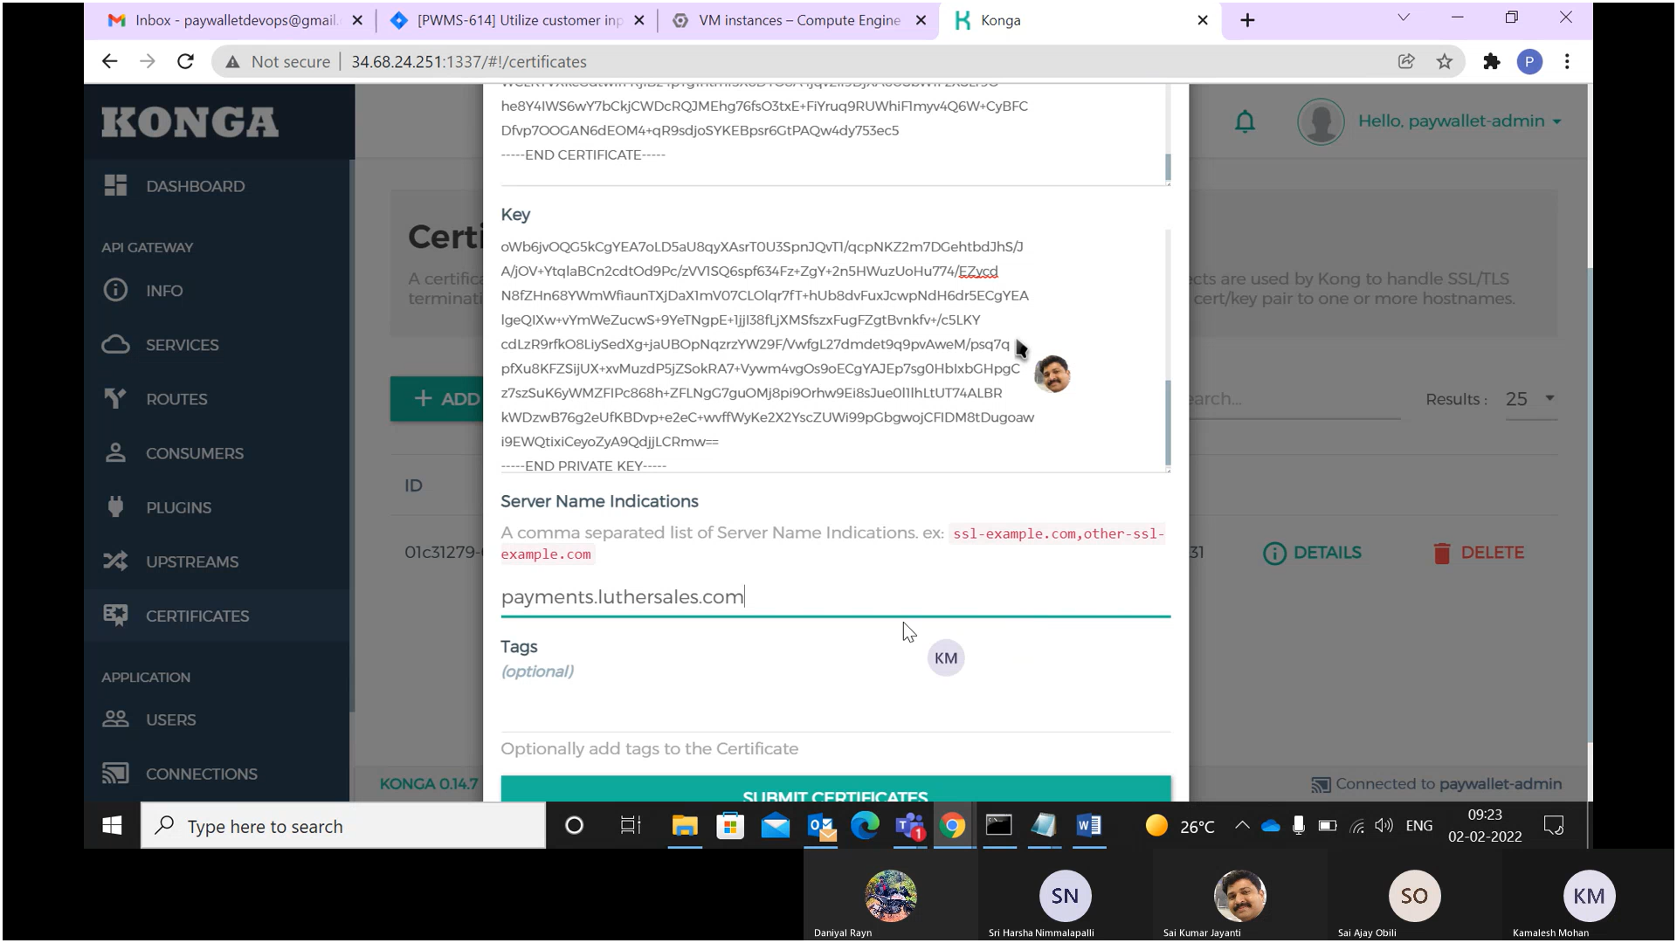

SUBMIT CERTIFICAT , REFRESH ONCES

NOW EVEN REFRESH IT ONCES IS ITS IS NOT UPDATED THE FOLLOW THESE LINE

GO TO THE TERMINAL

docker ps -s

docker restart 03b8e9f151cc

then just check in incognito window just check

(payments.luthersales.com)

then check

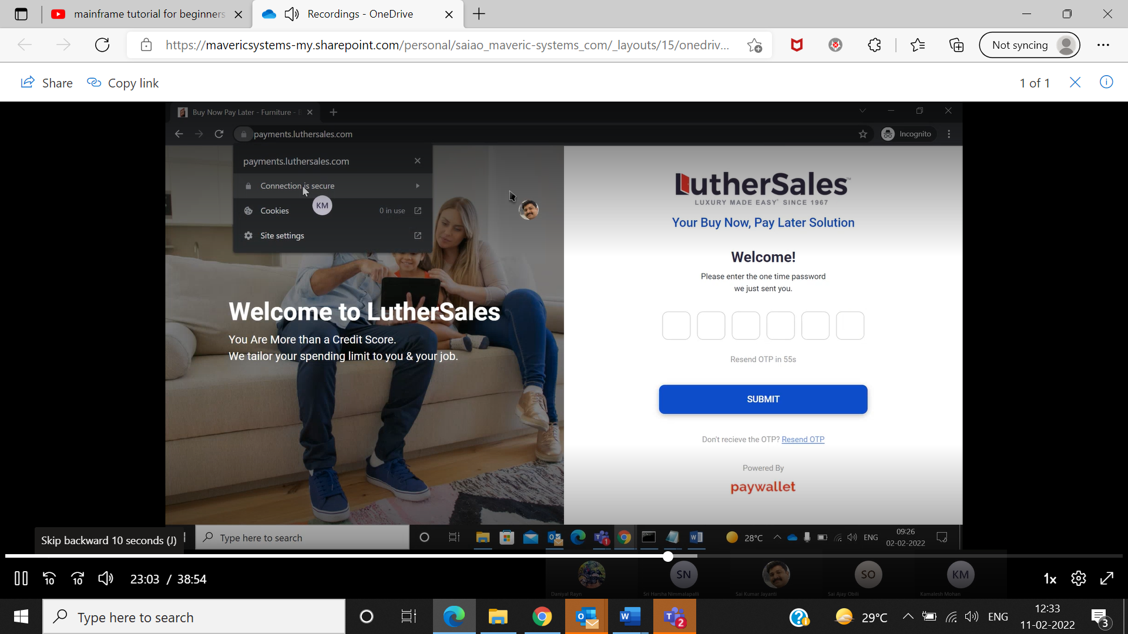

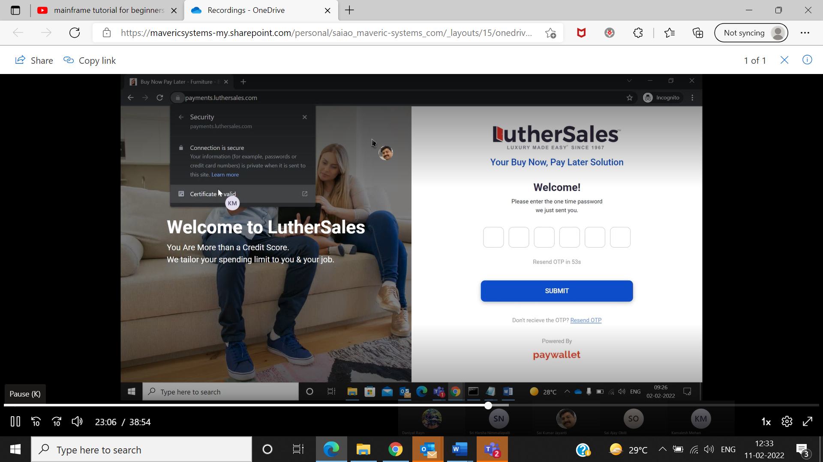

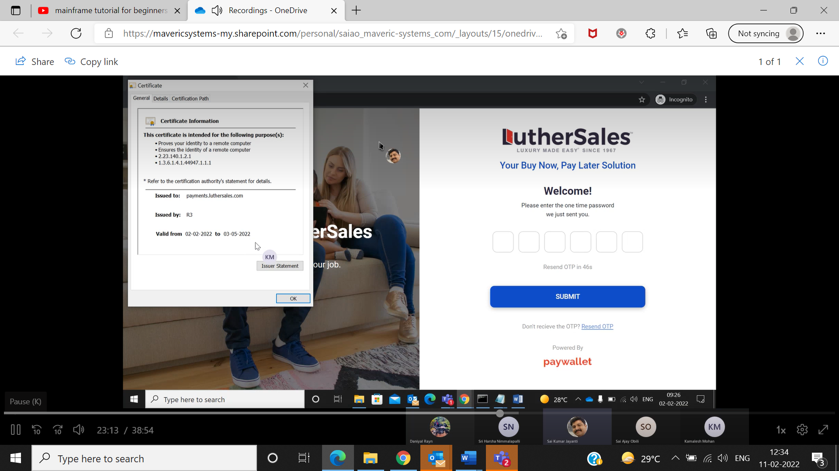

Now you can check whether certificate is updated or not …

Now we need to check and updated in KEYCLOAK

JUST GO THE PROD CREDENTAIL ( <https://payments.luthersales.com/auth/>)

Paste in search box same as what we did in previous line

And check wheather the certificate is valid or not

IF IT IS NOT UPDATE THEN GO TO THE TERMINAL GIVE COMMAND

Docker inspect 04b then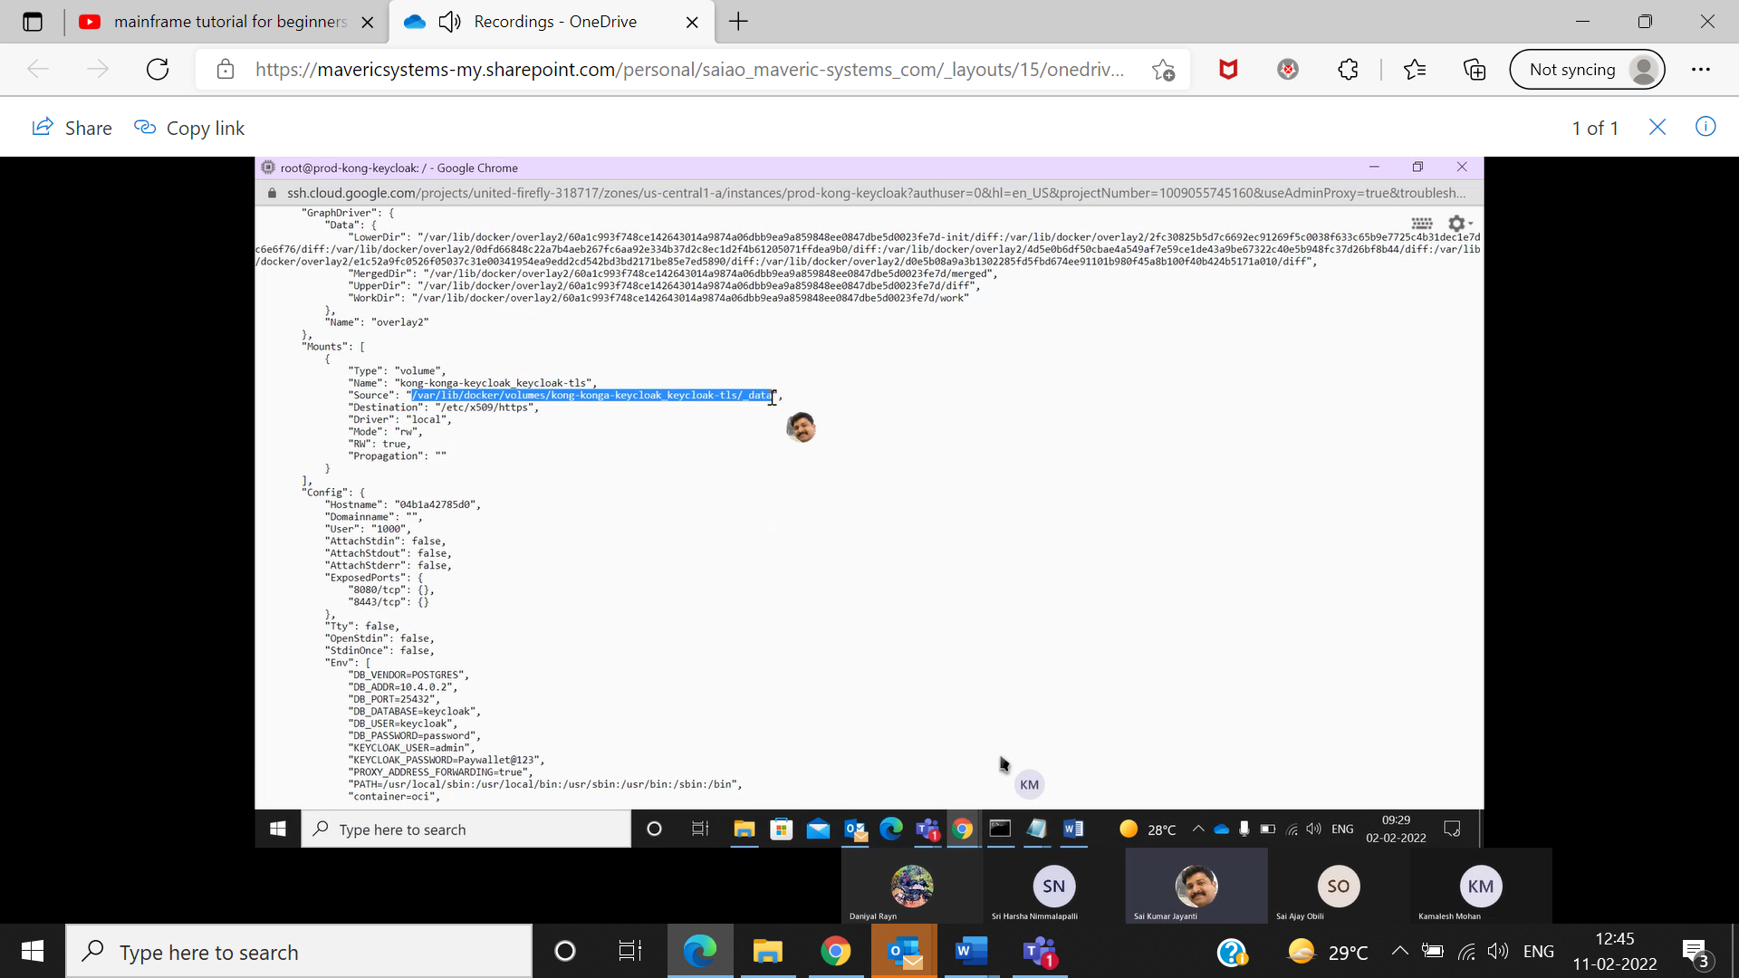

Then we need to go to this directory which is highlighted

So then give enter enter

Type the command

Cd/var/lib/docker/

ls

cd volumes/

ls -l

cd \*tls

ls -l

cd -data

ls -l

we need to the copy the

tls.cert

tls.key so we need to give

then

mv tls.crt /tmp

mv tls.key /tmp

cp /etc/letsencrypt/live/payments.luthersales.com

cp /etc/letsencrypt/live/payments.luthersales.com/fullchain.pem tls.cert

cp /etc/letsencrypt/live/payments.luthersales.com/privatekey.pem tls.key

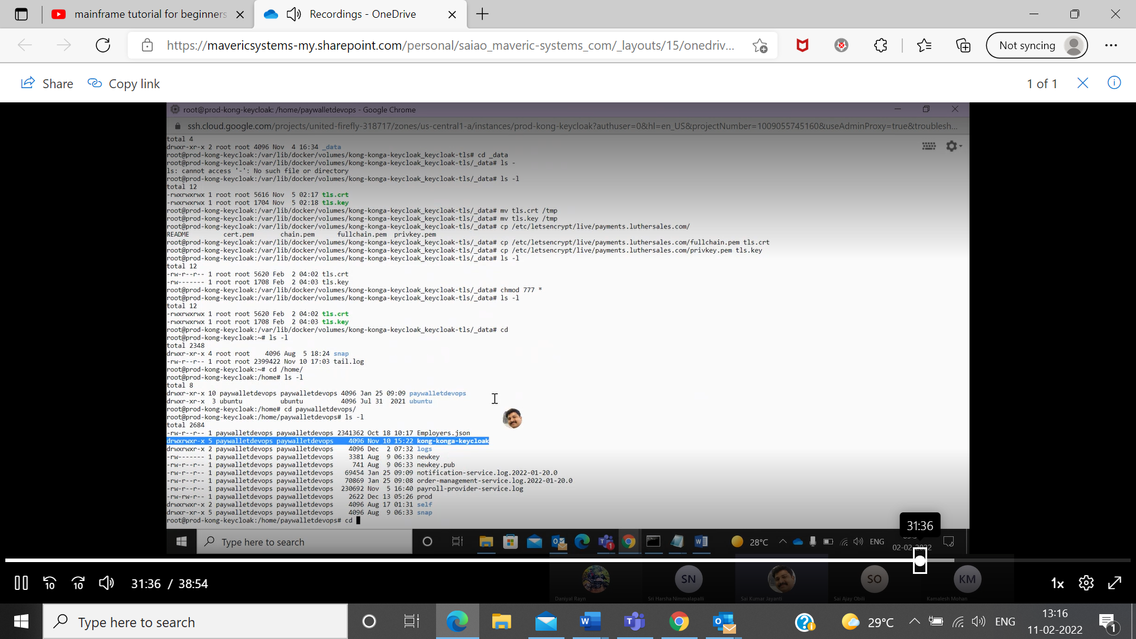

cd

ls -l

cd /home/

ls -l

cd paywalletdevops/

ls -l

cd konga-konga-keycloak/ls-l

cat docker-compose.yml

docker ps -a

now we need to delete this container and we need to recreate this

docker rm -f 04b

docker -compose up -d

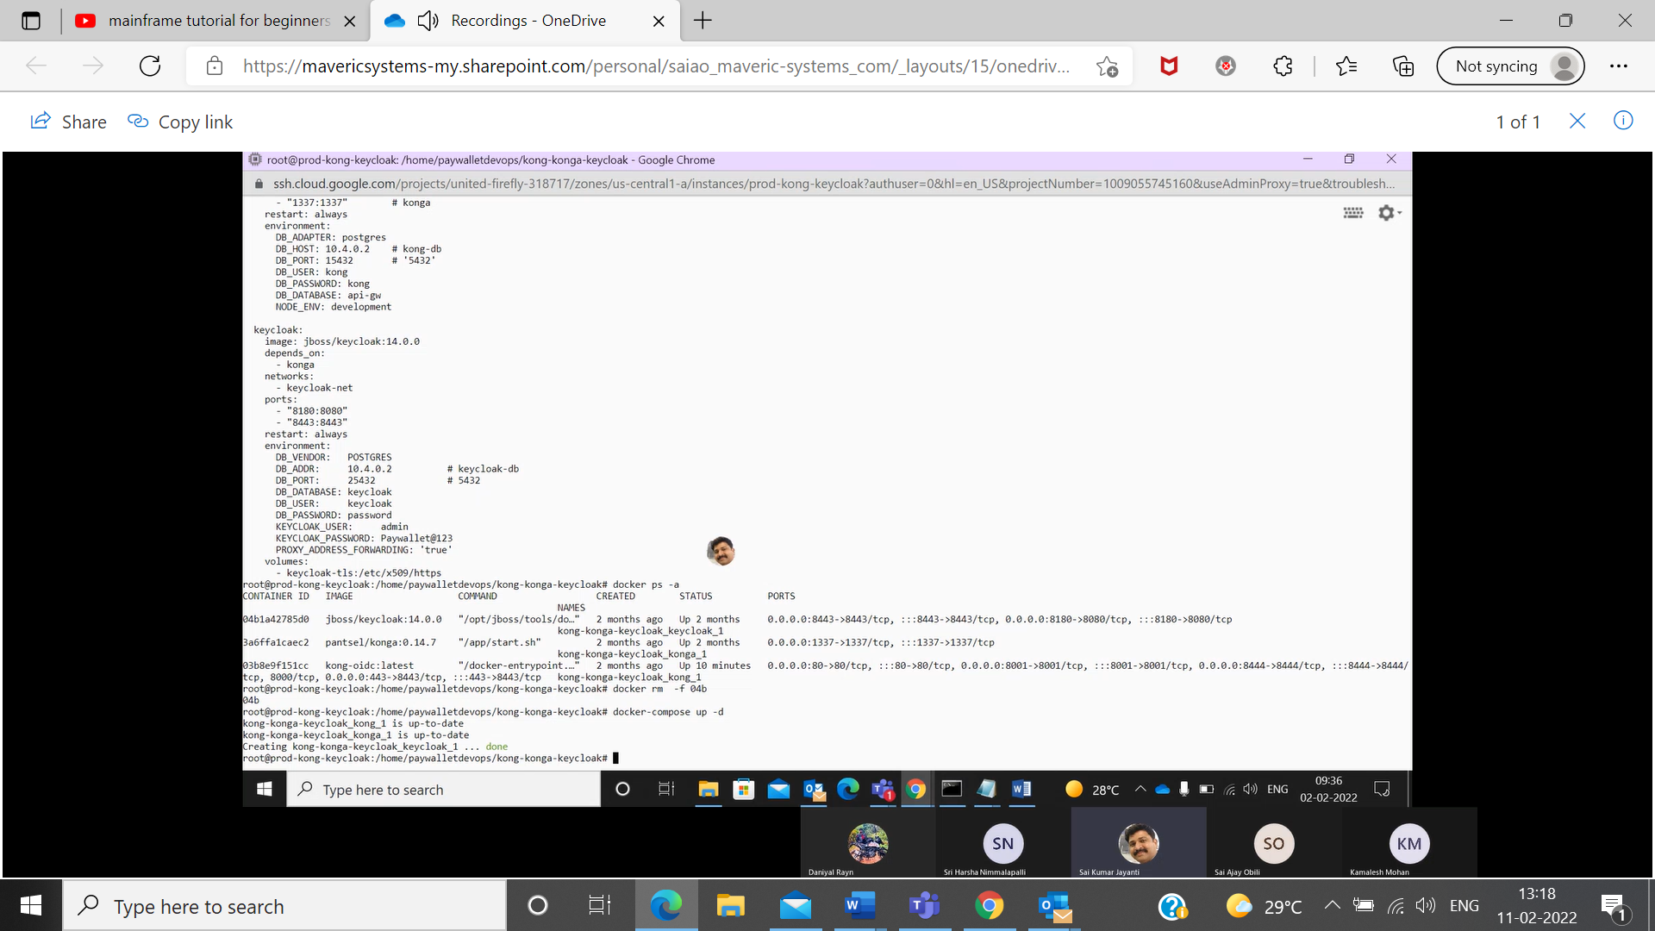

Just refer the images if could find any douth while those…

And after that just go to the incognito window and then check onces the certificate ketcloak has updated if it is not at updated just refresh and wait for 5 min then it will update…